

ADULT PERFORMANCE CLASSES FOR
DANCE FACTORY’S END OF TERM PERFORMANCE!

COMMENCING 24th APRIL 2021!

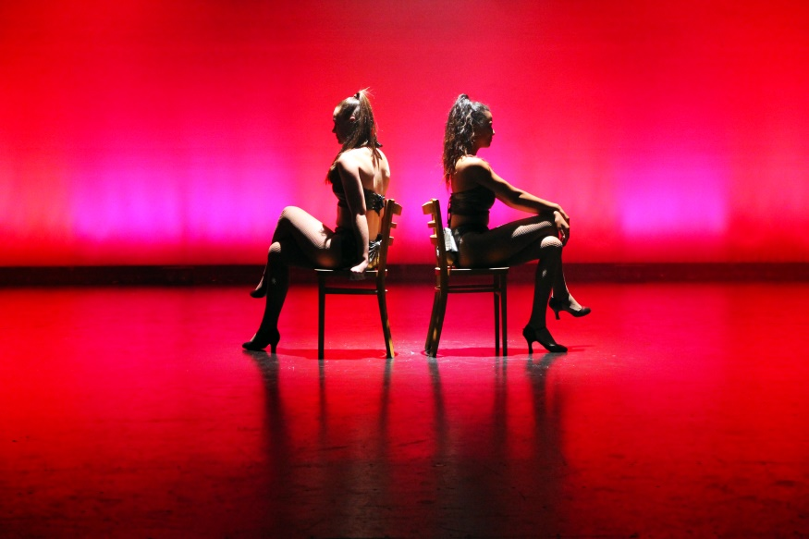

JAZZ SATURDAYS 10.30-11.15AM
HIP HOP SATURDAYS 11.15AM-12PM
LYRICAL SATURDAYS 12-12.45PM

Performance: Sunday 20th June

PLEASE FILL IN THE ATTACHED FORM TO REGISTER YOUR PLACE!

DANCE FACTORY
225 SWAN ST RICHMOND VIC 3121
PH (03) 9429 9492 dancefac@netspace.net.au
dancefactory.com.au
It is compulsory to purchase at least 2 tickets for the performance.
Performance classes cannot be made up if missed.

PERFORMANCE CLASS PAYMENT SLIP

PLEASE RETURN WITH PAYMENT TO DANCE FACTORY

Name:

Phone Number:

Address:

Email:

Please list performance classes you would like to enrol in:

1 4

2 5

3

List other classes you would like to include in your term payment:

1

2

3

PRICES
1 class per week $190 4 classes per week $680
2 classes per week $360 5 classes per week $825
3 classes per week $525 6 classes per week $960

Payment can be made by cash, cheque, eftpos/credit card facilities, credit card by phone or bank transfer:
BSB- 063 166 ACC NO- 1002 4887 (Please enter your name in the description field)
If you would like us to debit your card, pleases fill in the details below and return to
Dance Factory.

Type of card: Card number:

Name on card:

Signature: Exp date: Verification No:
TOTAL NUMBER OF CLASSES: TOTAL $

